工具：

1.babel，is a toolchain that is mainly used to convert ECMAScript 2015+ code into a backwards compatible version of JavaScript in current and older browsers or environments. <https://babeljs.io/docs/en/>

Babel的代码转换是基于plugin的。例如转换ES2015+的代码为ES5，可以通过加入官方plugin @babel/plugin-transform-arrow-functions,这样所有的箭头函数都会被转换成ES5兼容的函数。可是ES2015+还有更多的新语法需要转换，为避免手动加入更多的plugin，我们可以设置预先加载@babel/preset-env来实现所有ES2015+新语法的转换。可通过babel cli或配置文件进行配置。

Cli方式：

npm install --save-dev @babel/preset-env ./node_modules/.bin/babel src --out-dir lib --presets=@babel/env

配置方式：

1）”package.json”

{ "name": "my-package",

"version": "1.0.0",

"babel": {

"presets": [ "@babel/env", { targets: { edge: "17", firefox: "60", chrome: "67", safari: "11.1", } ],

"plugins": [ ... ], } }

2)其它，参见<https://babeljs.io/docs/en/configuration>

2.rollup, the ES6 revision of JavaScript, which includes a syntax for importing and exporting functions and data so they can be shared between separate scripts. But it is only implemented in modern browsers and not finalised in Node.js.  Rollup allows you to write your code using the new module system, and will then compile it back down to existing supported formats such as CommonJS modules, AMD modules, and IIFE-style scripts. In addition to enabling the use of ES modules, Rollup also statically analyzes the code you are importing, and will exclude anything that isn't actually used. This allows you to build on top of existing tools and modules without adding extra dependencies or bloating the size of your project. <https://rollupjs.org/guide/en>

3. uglify,  is a JavaScript parser, minifier, compressor and beautifier toolkit. <https://www.npmjs.com/package/uglify-js>

4. grunt.

<https://www.cnblogs.com/well-nice/p/4801408.html>

“gruntfile.js”, 为了grunt做某种配置的。按照grunt的规定，首先把gruntfile.js配置成如下格式：

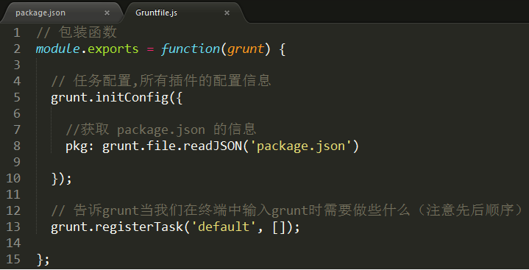

-grunt插件

进入grunt官网的插件列表页面 <http://www.gruntjs.net/plugins> ，我们能看到grunt到目前位置的所有插件。插件分为两类。第一类是grunt团队贡献的插件，这些插件的名字前面都带有“contrib-”前缀，而且在插件列表中有星号标注。第二类是第三方提供的插件，不带有这两个特征。下载前几名的插件包括：

* Contrib-jshint——javascript语法错误检查；
* Contrib-watch——实时监控文件变化、调用相应的任务重新执行；
* Contrib-clean——清空文件、文件夹；
* Contrib-uglify——压缩javascript代码
* Contrib-copy——复制文件、文件夹
* Contrib-concat——合并多个文件的代码到一个文件中
* karma——前端自动化测试工具

uglify插件的使用：

1. 安装uglify插件



1. gruntfile.js中做配置
2. grunt.initConfig方法中配置uglify的配置参数，例如：

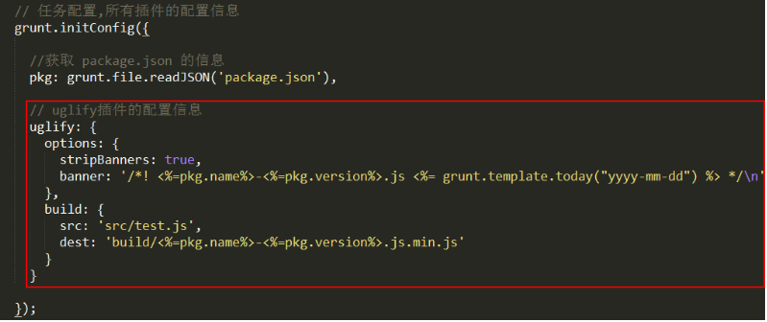

1. 如果要在grunt命令执行时立即执行uglify插件，加上如下registerTask:

